**Lesson 2 – Levels A1 - A2**

1. Introduce yourself to your group. Answer the following questions:

What’s your name?

How old are you?

Where are you from?

What do you do?

2. Write some sentences about your classmates.

3. Simple Present / Question words – Take notes about what your teacher is going to explain.

4. Guess who – Choose someone famous and think about his/her appearance, profession, routine… Tell your friends about it so they can guess who you’re talking about.

5. Choose the correct option for the following questions:

a. What does Todd do?

He’s a doctor.

He’s a pilot.

He’s a teacher.

b. What time does he get up?

At 9a.m.

Around 8:00.

Around 6:00s

c. When does he get home?

At 4p.m.

At night.

At midday.

d. Where does he go to have fun?

To the club.

To the mountains.

To the pool.

e. Who does he live with?

He lives alone.

He lives with his wife.

He lives with a roommate.

f. What does he do on Sunday?

He plays sports.

He goes to the gym.

He cleans his house.

g. Why do people get mad at him on the road?

Because he has an old car.

Because he drives slowly.

Because he drives too fast.

h. How often does Todd see his family.

Once a week.

Once a month.

Once a year.

i. How is winter like where his family lives?

It’s too cold.

It’s sunny.

The weather is nice.

6. Write 5 sentences about the topics of the listening using the Simple Present tense. (work, free time, family…)

7. It’s time to have conversation. Turn your affirmative sentences into questions and ask your classmates. Do you have anything in common?

8. Ask your partner questions so you can fill in your text. 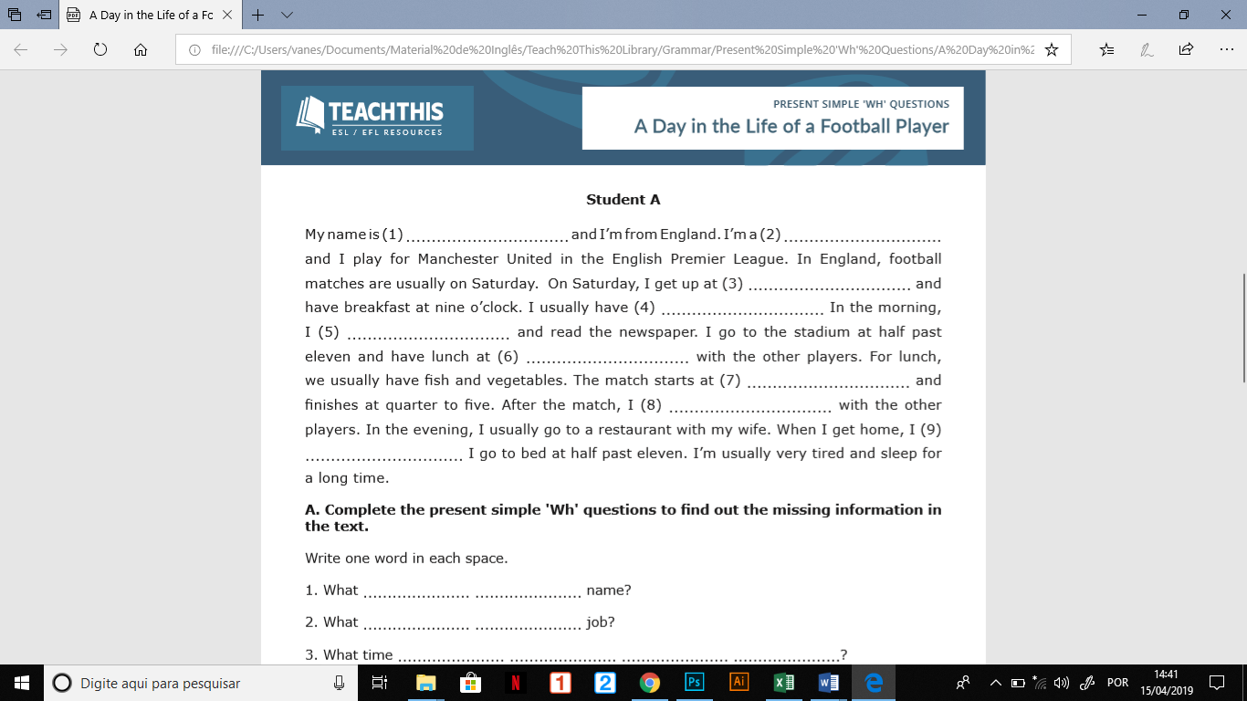

1.

2.

3.

4.

5.

6.

7.

8.

9.

10.

11.

12.

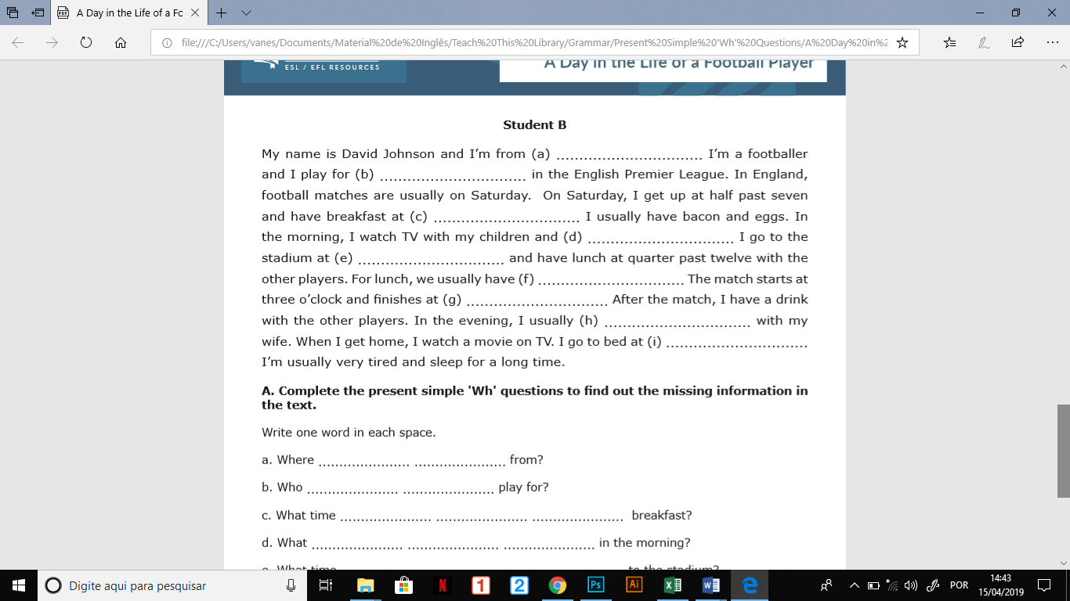

1. England

2. Munchester United

3. 9 o’ clock

4.read the newspaper

5. half past eleven

6. fish and vegetables

7. 4:45pm

8.go to a restaurant

9. half past eleven

10.

11.

12.

9. Quizlet live – 100 most common verbs.

10. Use the vocabulary below to write sentences about the movie trailer you watched.

     

Buddy

Mel

Gidget

Sweetpea

Chloe

Max

   

Leonard and its friends

The pets’ owners

Tino

Leonard

|  |  |  |  |  |
| --- | --- | --- | --- | --- |
| eat | play | squirrels | video games | massage |
| hate | the radio | a busy day | rock & roll | in a castle |
| wait | work | like | talk | live |

1.

2.

3.

4.

5.

11. Read the text and answer the questions:

**Teenagers’ food habits**

Doctors in Britain are worried because British teenagers eat lots of crisps, sweets and fat food. Most teenagers don’t eat enough fruit or vegetables and more than one million British school children are overweight.

Some teenagers say that they don’t have time to eat good food, but kids who have a poor diet often have health problems when they are older.

Americans have been familiar with fast food for a long time, it was invented there. American fast food is now part of life far beyond the stores of the United States. McDonald’s, Pizza Hut, Burger King have restaurants all over the world.

No one can deny that the idea of fast food at a fair price has its place around the world. These establishments are popular not simply because they are fulfilling a need within a particular country’s economy, but also because they serve what is called comfort food which makes people feel happy.

A steady diet of burgers, fries and soda may seem delicious, but it won’t nourish your body with vitamins and minerals you need to stay healthy. Fast food lacks many important nutrients.

Now doctors are giving young people books and games about a good diet. Having healthy, well-balanced diet can help you feel better and live longer.

a. Why are doctors worried?

b. What fast food chains does the text mention. Which one is your favorite? Why?

c. Why is a diet with too much fast food bad for your body?

d. How often do you eat fast food?

c. What do you usually eat at lunch?